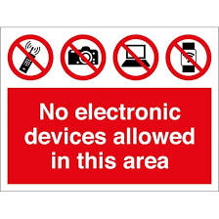
ATTENTION STUDENTS: EFFECTIVE 1/30/23:

Upon Entry into this class, you MUST:

Turn off your cell phone and place it in the cell phone caddy
Remove all headphones and air pods
Close all outside laptops and put them away
Shut down and put away all handheld games and tablets

Failure to do so will result in:
1st Offense: Half-hour after school detention: always on Fridays
2nd Offense: One-hour after school detention: always on Fridays
3rd Offense: One-day suspension
4th Offense: Three-day suspension
5th Offense: Dismissal from EHS
***Refusal to turn in device will result in automatic parent contact***
***If your parents need to contact you, they MUST call the main office: 586-439-4407.

